**SHACMAN H3000 8X4 DUMP Truck自卸车**

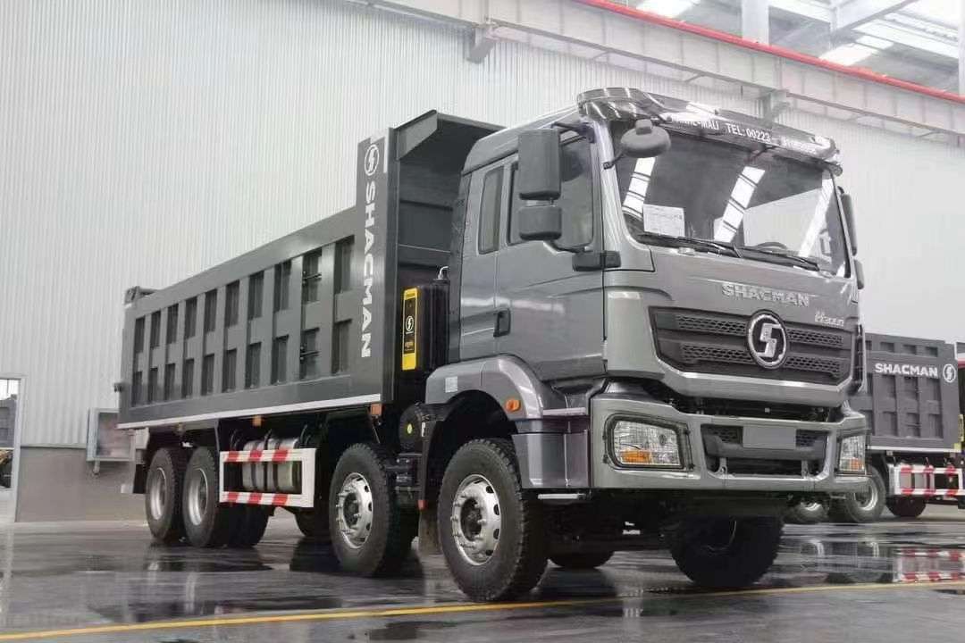

图片仅供参考

Pictures are for reference only

**Main Specifications主要参数**

|  |  |  |
| --- | --- | --- |
| MODEL/车型 | | SX3318MT366 |
| Driver position/驾驶员位置 | | 左舵 Left Hand |
| Driving type/驱动形式 | | 8*4 |
| Wheelbase/轴距(mm) | | 1800+3575+1400 |
| Max. Speed/最高车速(km/h) | | 75km/h |
| Engine/发动机 | Brand/品牌 | WEICHAI/潍柴 |
| Model/型号 | WP10.375E50 |
| Emission Standard/排放 | EURO V |
| Rated output power/功率（PS） | 375 |
| Displacement  (L)/排量 | 9.726L |
| Transmission/变速箱 | Brand/品牌 | FAST/法士特 |
| Model/型号 | 10JSD180T-B-铁壳  QH50 |
| Front axle/前轴 | Brand/品牌 | 汉德牌/HANDE |
| Model/型号 | MAN 9.5T |
| Rear axle/后桥 | Brand/品牌 | 汉德牌/HANDE |
| Model/型号 | 16T MAN双级桥 double reduction driving axle  Speed ratio 速比：5.262 |
| Clutch/离合器 | | ￠430 diaphragm clutch￠430离合器 |
| Steering/转向机 | | ZF technology/ ZF技术 |
| Frame/车架 | | 850x300(8+7) |
| Suspension/悬架 | | Front and rear multi-leaf spring four main flims+four horse riding  前后多片簧  四主片+四  骑马 |
| Fuel tank/燃油箱 | | 400L铝合金 Aluminum alloy |
| Wheels and tires/轮胎 | | 12.00R20 |
| Brakes/制动 | | Running brake:Dual circuit compressed air brake/行车制动 |
| Parking brake:Air discharging with spring control/停车制动 |
| Auxiliary brake:Engine exhaust brake/发动机排气辅助制动 |
| Cabin/驾驶室 | | 空气主座椅、四点空气悬浮驾驶室、电控自动恒温空调、电动摇窗机、手动翻转、普通空滤、、平板安装板、金属保险杠、铰链式上车踏板、分体式挡泥板、165Ah维护蓄电池、SHACMAN识、全英文标识 |
| Air main seat, four-point air suspension cab, electronically controlled automatic constant temperature air conditioner, electric window shaker, manual flip, ordinary air filter, ordinary 90 saddle, flat mounting plate, metal bumper, hinged upper car  Pedals, split fenders, 165Ah maintenance battery , SHACMAN logo, full English logo |
| Upbody/上装 | | 7400*2300*1500 |

|  |
| --- |
|  |
| Description/说明：   1. Terms of payment: T/T, 30% deposit, balance before delivery from factory.   支付条件：预付30%，工厂发车前付清尾款   1. Delivery at China port period: 45 working days after advance payment.   交货期：预付款后45个工作日到国内港口   1. Vehicle warranty period: 24 months from the date of bill of lading.   整车质保期：提单之日起24个月 |